Analysis of Bucket Sort

* What is the cost of the calls to Insertion Sort?
  + Let *n****i*** be the random variable denoting the number of elements in bucket B[i]
  + And we know that Insertion Sort runs in Ο(*n2*) time

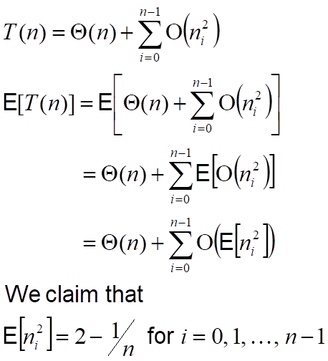

* + To prove the above equation, define indicator random variables
    - *X****ij*** = I{A[*j*] falls into bucket *i*]
      * for *i* = 0, 1, …, *n*-1
      * for *j* = 1, 2, …, *n*
  + Thus…

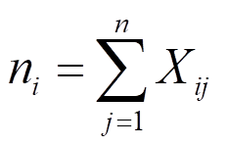

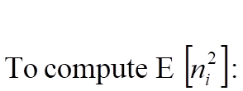

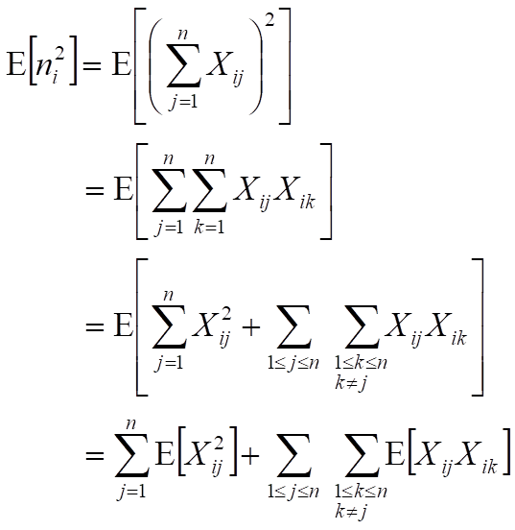

* Evaluate the two summations separately

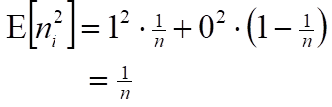

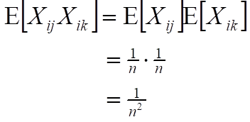

* Substitute these into EQ 8.3

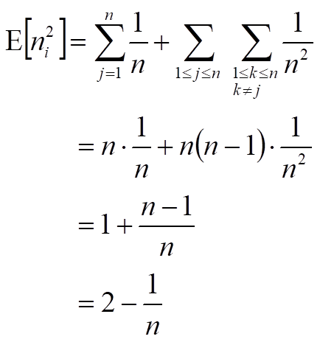

* Use the expected value in EQ 8.1

